**Student name: Trevor Cardoza SMC username: tmc12**

Instructions: Fill out your full name and SMC username above. Answer each question in its respective following space. **Give a sufficient yet succinct answer for each question and show results / figures / tables / graphs on this same sheet when appropriate or explicitly requested.** After completion, rename and save this file as **“Assignment 2_BUSAD 137_*your full name*” in either MS Word (.docx or .doc) or PDF (.pdf) format** then upload and submit it **together with the completed Excel files** on Moodle by the due date. No other file formats will be accepted. A late or email submission will NOT be accepted.

**Total possible points: 120 points**

1. **All-integer linear program (50 points in total)**

STAR Co. provides paper to smaller companies with volumes that are not large enough to warrant dealing directly with the paper mill. STAR receives 100-feet-wide paper rolls from the mill and cuts the rolls into smaller rolls of widths 12, 15, and 30 feet. The demands for these widths vary from week to week. The following cutting patterns have been established:

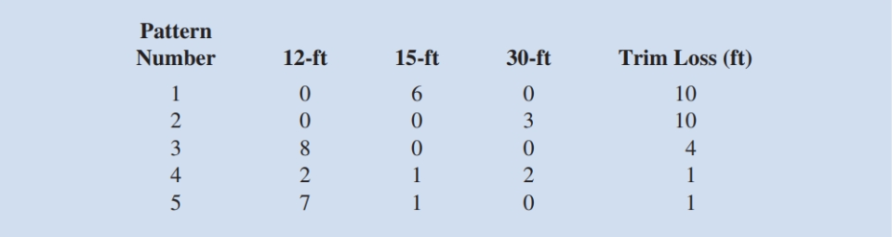

Trim loss is the leftover paper from a pattern (for example, for pattern 4, 2(12) + 1(15) + 2(30) = 99 feet used results in 100 – 99 = 1 foot of trim loss). Demands this week are 5670 12-foot rolls, 1680 15-foot rolls, and 3350 30-foot rolls. The company wants to determine how many 100-foot rolls to cut into each of the five patterns in order to meet demand and minimize trim loss (leftover paper from a pattern).

1.1 What is the all-integer linear program for this problem expressed in the mathematical form? Write down the entire mathematical model in the following space including the explicit and implicit constraints. Let xj = number of 100-foot rolls using cutting pattern j (j = 1, 2, 3, 4, 5). (15 points)

Min x1(10)+ x2(10)+ x3(4)+ x4(1)+ x5(1)

x3(8)+ x4(2)+ x5(7) >= 5670

x1(6)+ x4(1)+ x5(1) >= 1680

x2(3)+ x4(2) >= 3350

1.2 Develop a spreadsheet model by completing the missing parts indicated by the bordered cells **except the five shaded cells** in the provided **STAR.xlsx** file and find the optimal solution using Excel Solver. Generate an **answer report** on a separate worksheet in the same Excel file. How many numbers of 100-foot rolls for each cutting pattern should STAR Co. use in order to achieve the optimal solution? (Note: remember to submit the completed STAR.xlsx file alongside with your answer sheet on Moodle.) (25 points)

Pattern 1: 0

Pattern 2: 0

Pattern 3: 0

Pattern 4: 1675

Pattern 5: 332

1.3 What is the minimized total trim loss STAR Co. can achieve in the optimal solution? How many actual 12-foot, 15-foot, and 30-foot rolls the company needs to produce in the optimal solution? (5 points)

Total Trim: 2007

12 Feet: 5674

15 Feet: 2007

30 Feet: 3350

1.4 Among the three explicit constraints, which ones are binding constraints? (5 points)

30 feet produced

1. **Binary mixed-integer linear program (70 points in total)**

Hart Manufacturing makes three products. Each product requires manufacturing operations in three departments: A, B, and C. The per-unit labor-hour requirements, by department, are as follows:

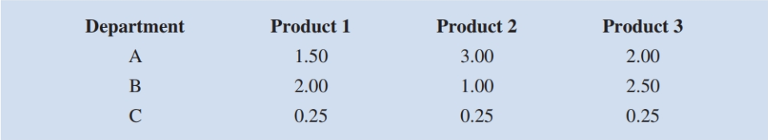

During the next production period the labor-hours available are 450 in department A, 350 in department B, and 50 in department C. The profit contributions per unit are $25 for product 1, $28 for product 2, and $30 for product 3.

The company also realizes that, in order to produce a specific type of product, it must set up a corresponding production facility which is associated with a setup cost and a maximum production capacity. It estimates that setup costs are $400 for product 1, $550 for product 2, and $600 for product 3. The company also states that the facility’s maximum production capacity for product 1 is 175 units, for product 2 is 150 units, and for product 3 is 140 units.

The company wants to determine how much of each product should be produced in order to maximize total profit contribution considering the possible setup costs.

2.1 What is the mixed-integer linear program for this problem expressed in the mathematical form? Write down the entire mathematical model in the following space including the explicit and implicit constraints. Let Pi = units of product i (i = 1, 2, 3) produced, and yi is a binary decision variable with value 1 if the production facility for product i is set up and value 0 otherwise. (20 points)

Max 25P1 + 28P2 + 30P3 – 400y1 – 550y2 – 600y3

yi = 1 or 0

Pi >= 0

P1 <= 175

P2 <= 150

P3 <= 140

P1(1.50)+P2 (3.00)+ P2 (2.00)<= 450

P1(2.00)+P2 (1.00)+ P2 (2.50)<= 350

P1(0.25)+P2 (0.25)+ P2 (0.25)<= 50

2.2 Develop a spreadsheet model by completing the missing parts indicated by the bordered cells **except the six shaded cells** in the provided **Hart.xlsx** file and find the optimal solution using Excel Solver. Generate an **answer report** on a separate worksheet in the same Excel file. According to the optimal solution, how much of each product should be produced? (Note: remember to submit the completed Hart.xlsx file alongside with your answer sheet on Moodle.) (35 points)

2.3 Among the three types of products, which products are produced as the corresponding production facilities are set up in the optimal solution? (5 points)

Product 1 and 2

2.4 What is the total profit contribution Hart Manufacturing can earn with the optimal solution? How many hours of actual production time will be scheduled in each department? (5 points)

$4,350

A: 450

B: 300

C: 50

2.5 Among the three time constraints (hours for department A, hours for department B, and hours for Department C), which constraint(s) are binding? What is the slack time in each department? (5 points)

hours for department A and hours for Department C

A: 0

B: 50

C: 0